**MIE1622 Assignment 2 Report**

**Yizhou Liu 1001139822**

1. Produce the following output for the 12 periods (years 2015 and 2016):

Period 1: start date 1/2/2015, end date 2/27/2015

Strategy "Buy and Hold", value begin = $ 1000002.12, value end = $ 1043785.08

Strategy "Equally Weighted Portfolio", value begin = $ 992871.44, value end = $ 1020334.04

Strategy "Minimum Variance Portfolio", value begin = $ 991454.17, value end = $ 1016180.61

Strategy "Maximum Sharpe Ratio Portfolio", value begin = $ 990052.61, value end = $ 1007859.90

Strategy "Equal Risk Contributions Portfolio", value begin = $ 992755.20, value end = $ 1018523.00

Strategy "Leveraged Equal Risk Contributions Portfolio", value begin = $ 989654.50, value end = $ 1041531.52

Strategy "Robust Optimization Portfolio", value begin = $ 991454.55, value end = $ 1016176.58

Period 2: start date 3/2/2015, end date 4/30/2015

Strategy "Buy and Hold", value begin = $ 1045234.09, value end = $ 1069877.19

Strategy "Equally Weighted Portfolio", value begin = $ 1031067.89, value end = $ 1011525.43

Strategy "Minimum Variance Portfolio", value begin = $ 1023412.52, value end = $ 1014243.81

Strategy "Maximum Sharpe Ratio Portfolio", value begin = $ 1017313.49, value end = $ 1056100.26

Strategy "Equal Risk Contributions Portfolio", value begin = $ 1029424.13, value end = $ 1014306.71

Strategy "Leveraged Equal Risk Contributions Portfolio", value begin = $ 1063306.57, value end = $ 1031173.64

Strategy "Robust Optimization Portfolio", value begin = $ 1023407.08, value end = $ 1014239.32

Period 3: start date 5/1/2015, end date 6/30/2015

Strategy "Buy and Hold", value begin = $ 1085647.24, value end = $ 1027659.63

Strategy "Equally Weighted Portfolio", value begin = $ 1021518.10, value end = $ 987742.27

Strategy "Minimum Variance Portfolio", value begin = $ 1009289.81, value end = $ 970162.87

Strategy "Maximum Sharpe Ratio Portfolio", value begin = $ 1057412.04, value end = $ 1015548.08

Strategy "Equal Risk Contributions Portfolio", value begin = $ 1023265.32, value end = $ 990714.23

Strategy "Leveraged Equal Risk Contributions Portfolio", value begin = $ 1050157.44, value end = $ 982163.03

Strategy "Robust Optimization Portfolio", value begin = $ 1009285.11, value end = $ 970153.45

Period 4: start date 7/1/2015, end date 8/31/2015

Strategy "Buy and Hold", value begin = $ 1035245.91, value end = $ 947793.98

Strategy "Equally Weighted Portfolio", value begin = $ 991618.31, value end = $ 934542.95

Strategy "Minimum Variance Portfolio", value begin = $ 972734.74, value end = $ 932825.67

Strategy "Maximum Sharpe Ratio Portfolio", value begin = $ 1011289.18, value end = $ 925499.96

Strategy "Equal Risk Contributions Portfolio", value begin = $ 995197.70, value end = $ 946408.82

Strategy "Leveraged Equal Risk Contributions Portfolio", value begin = $ 991542.96, value end = $ 894116.62

Strategy "Robust Optimization Portfolio", value begin = $ 972726.13, value end = $ 932817.03

Period 5: start date 9/1/2015, end date 10/30/2015

Strategy "Buy and Hold", value begin = $ 912055.56, value end = $ 1027307.87

Strategy "Equally Weighted Portfolio", value begin = $ 904735.62, value end = $ 1022936.74

Strategy "Minimum Variance Portfolio", value begin = $ 900886.58, value end = $ 941137.54

Strategy "Maximum Sharpe Ratio Portfolio", value begin = $ 880517.38, value end = $ 1099098.65

Strategy "Equal Risk Contributions Portfolio", value begin = $ 915603.34, value end = $ 1027792.49

Strategy "Leveraged Equal Risk Contributions Portfolio", value begin = $ 832578.64, value end = $ 1053713.89

Strategy "Robust Optimization Portfolio", value begin = $ 901440.04, value end = $ 942506.81

Period 6: start date 11/2/2015, end date 12/31/2015

Strategy "Buy and Hold", value begin = $ 1039856.20, value end = $ 1003328.46

Strategy "Equally Weighted Portfolio", value begin = $ 1039893.88, value end = $ 1035339.80

Strategy "Minimum Variance Portfolio", value begin = $ 945637.98, value end = $ 960129.18

Strategy "Maximum Sharpe Ratio Portfolio", value begin = $ 1102151.74, value end = $ 1216470.72

Strategy "Equal Risk Contributions Portfolio", value begin = $ 1041901.25, value end = $ 1041868.37

Strategy "Leveraged Equal Risk Contributions Portfolio", value begin = $ 1081295.84, value end = $ 1081167.07

Strategy "Robust Optimization Portfolio", value begin = $ 948624.28, value end = $ 956873.87

Period 7: start date 1/4/2016, end date 2/29/2016

Strategy "Buy and Hold", value begin = $ 994608.85, value end = $ 970570.87

Strategy "Equally Weighted Portfolio", value begin = $ 1014986.39, value end = $ 954593.97

Strategy "Minimum Variance Portfolio", value begin = $ 949291.10, value end = $ 944795.17

Strategy "Maximum Sharpe Ratio Portfolio", value begin = $ 1175381.51, value end = $ 1007400.01

Strategy "Equal Risk Contributions Portfolio", value begin = $ 1021460.37, value end = $ 954150.01

Strategy "Leveraged Equal Risk Contributions Portfolio", value begin = $ 1039779.95, value end = $ 905372.29

Strategy "Robust Optimization Portfolio", value begin = $ 944998.88, value end = $ 940484.66

Period 8: start date 3/1/2016, end date 4/29/2016

Strategy "Buy and Hold", value begin = $ 999683.25, value end = $ 975547.52

Strategy "Equally Weighted Portfolio", value begin = $ 982585.52, value end = $ 1052713.07

Strategy "Minimum Variance Portfolio", value begin = $ 956400.31, value end = $ 989141.91

Strategy "Maximum Sharpe Ratio Portfolio", value begin = $ 1030825.34, value end = $ 1002665.85

Strategy "Equal Risk Contributions Portfolio", value begin = $ 982333.36, value end = $ 1055983.94

Strategy "Leveraged Equal Risk Contributions Portfolio", value begin = $ 961658.45, value end = $ 1108905.90

Strategy "Robust Optimization Portfolio", value begin = $ 952038.22, value end = $ 984654.22

Period 9: start date 5/2/2016, end date 6/30/2016

Strategy "Buy and Hold", value begin = $ 982170.01, value end = $ 1000838.49

Strategy "Equally Weighted Portfolio", value begin = $ 1066039.38, value end = $ 1107801.14

Strategy "Minimum Variance Portfolio", value begin = $ 993643.75, value end = $ 1062960.40

Strategy "Maximum Sharpe Ratio Portfolio", value begin = $ 1006517.88, value end = $ 1094312.21

Strategy "Equal Risk Contributions Portfolio", value begin = $ 1069114.76, value end = $ 1115904.53

Strategy "Leveraged Equal Risk Contributions Portfolio", value begin = $ 1135122.74, value end = $ 1234612.61

Strategy "Robust Optimization Portfolio", value begin = $ 989136.22, value end = $ 1058150.51

Period 10: start date 7/1/2016, end date 8/31/2016

Strategy "Buy and Hold", value begin = $ 1003605.67, value end = $ 1067751.34

Strategy "Equally Weighted Portfolio", value begin = $ 1118897.99, value end = $ 1224937.26

Strategy "Minimum Variance Portfolio", value begin = $ 1063264.62, value end = $ 1049359.77

Strategy "Maximum Sharpe Ratio Portfolio", value begin = $ 1093737.04, value end = $ 1115233.23

Strategy "Equal Risk Contributions Portfolio", value begin = $ 1126007.12, value end = $ 1236733.64

Strategy "Leveraged Equal Risk Contributions Portfolio", value begin = $ 1255067.72, value end = $ 1476706.84

Strategy "Robust Optimization Portfolio", value begin = $ 1058489.93, value end = $ 1043991.88

Period 11: start date 9/1/2016, end date 10/31/2016

Strategy "Buy and Hold", value begin = $ 1073361.15, value end = $ 1090939.15

Strategy "Equally Weighted Portfolio", value begin = $ 1226779.94, value end = $ 1225360.36

Strategy "Minimum Variance Portfolio", value begin = $ 1045777.93, value end = $ 1020358.92

Strategy "Maximum Sharpe Ratio Portfolio", value begin = $ 1114010.73, value end = $ 1177006.94

Strategy "Equal Risk Contributions Portfolio", value begin = $ 1238045.17, value end = $ 1235879.33

Strategy "Leveraged Equal Risk Contributions Portfolio", value begin = $ 1479332.27, value end = $ 1474999.78

Strategy "Robust Optimization Portfolio", value begin = $ 1041225.41, value end = $ 1015924.76

Period 12: start date 11/1/2016, end date 12/30/2016

Strategy "Buy and Hold", value begin = $ 1077523.53, value end = $ 1173675.24

Strategy "Equally Weighted Portfolio", value begin = $ 1211690.01, value end = $ 1349610.80

Strategy "Minimum Variance Portfolio", value begin = $ 1006922.65, value end = $ 1120982.74

Strategy "Maximum Sharpe Ratio Portfolio", value begin = $ 1156930.40, value end = $ 1535186.44

Strategy "Equal Risk Contributions Portfolio", value begin = $ 1224586.24, value end = $ 1370331.91

Strategy "Leveraged Equal Risk Contributions Portfolio", value begin = $ 1452418.45, value end = $ 1744364.00

Strategy "Robust Optimization Portfolio", value begin = $ 1002554.51, value end = $ 1116121.73

* Plot one chart in MATLAB that illustrates the daily value of your portfolio (for each of the seven trading strategies) over the years 2015 and 2016 using daily prices provided.

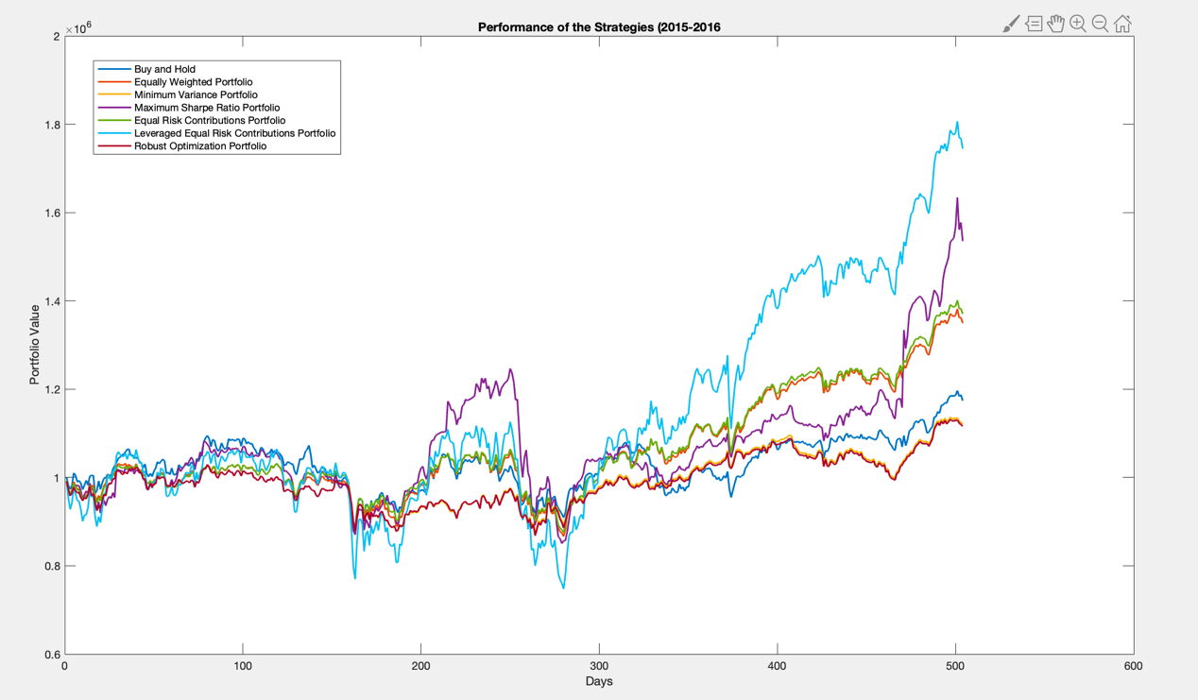

* Plot one chart in MATLAB to show dynamic changes in portfolio allocations under strategy 7.

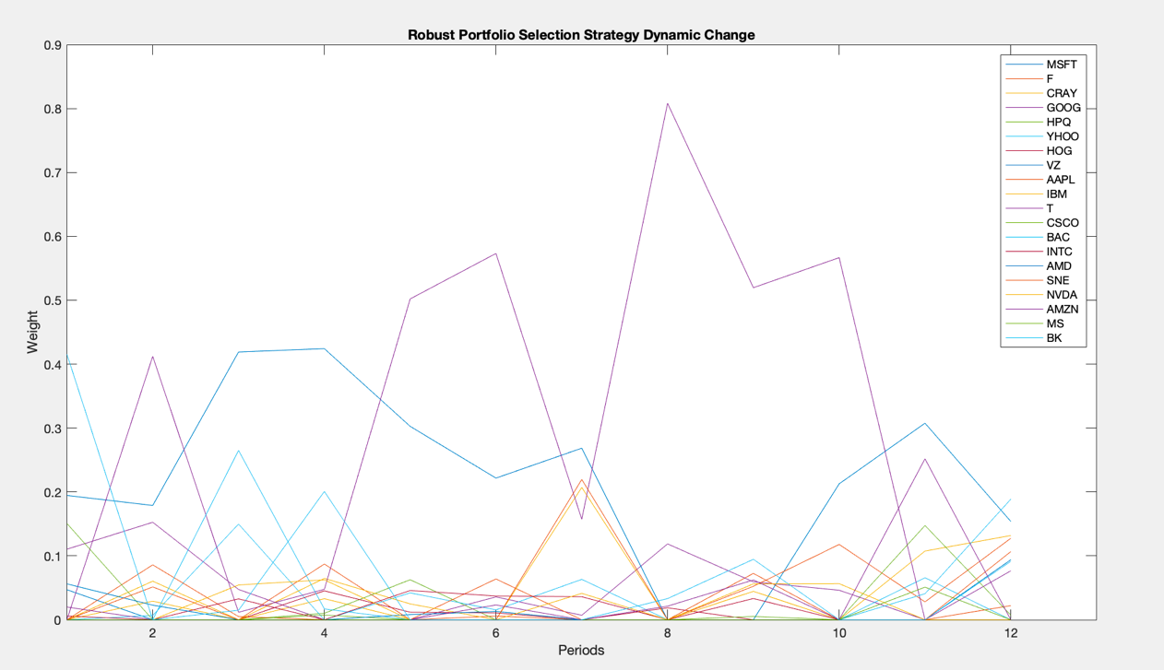

* Dynamic changes in portfolio allocations under strategy 3.

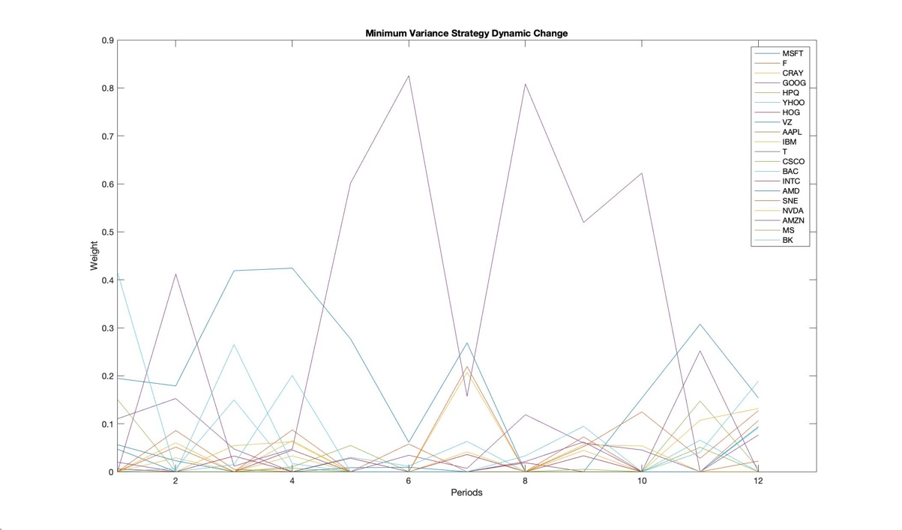

* Dynamic changes in portfolio allocations under strategy 4.

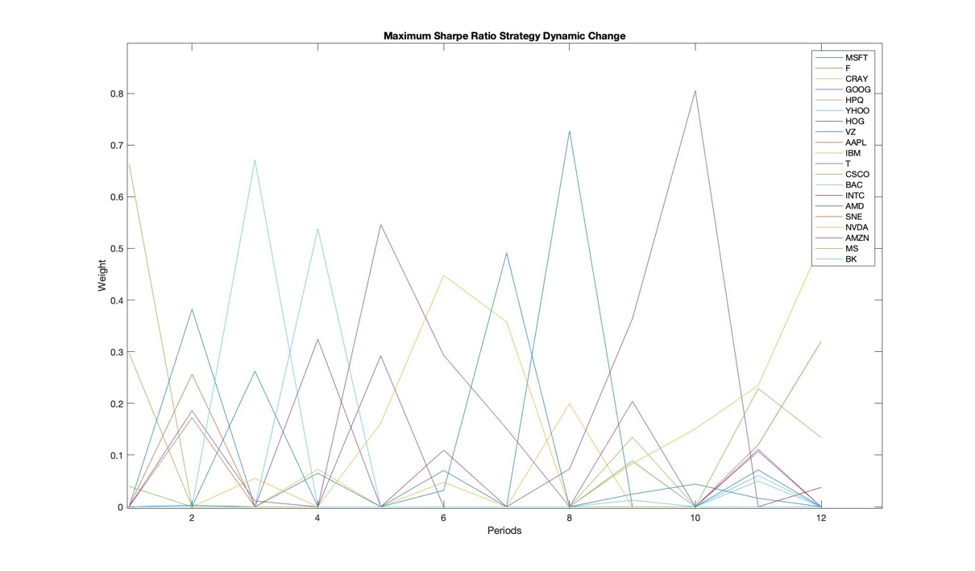

* Does your robust portfolio selection strategy reduce trading as compared with strategies 3 and 4?

The robust portfolio selection strategy reduces trading as compared with minimum variance strategy and maximum Sharpe ratio strategy. It is obvious that the change of weight across periods for each asset represents the trading status. According to dynamic change figures, the dynamic change for robust strategy and minimum variance strategy seems are similar, but robust strategy would be more stable, so robust portfolio selection strategy reduces trading as compared with strategy 3. The ups and downs of maximum Sharpe ratio strategy are dramatic, so robust portfolio selection strategy reduces trading as compared with strategy 4.

* Compare your “equal risk contributions”, “leveraged equal risk contributions” and “robust mean-variance optimization” trading strategies between each other and to four strategies in a1 and discuss their performance relative to each other. Which strategy would you select for managing your own portfolio and why?

For the Equal Risk Contribution strategy, individual assets have equal risk contribution to the portfolio risk. For the Leveraged Equal Risk Contribution strategy, we borrow the money, which equals to the initial value of portfolio, in the first period and pay interest for each period throughout two years. For the Robust Mean-variance Optimization strategy, it is an improvement of mean-variance portfolio strategy, which makes the uncertainty set of expected return distribution feasible under the worst case. It is an conservative strategy.

Based on the output and the Performance of the Strategies plot over 2015 and 2016, after 12 periods (2 years), the Leveraged Equal Risk Contribution Strategy would produce the highest portfolio value and Robust Mean-Variance Optimization strategy would produce the lowest portfolio value. The reason might be that the initial value of Leveraged Equal Risk portfolio has been doubled. So the ups and downs of portfolio value over two years are more dramatic than the Equal Risk portfolio. When the value of Equal Risk portfolio increases, the value of Leverage Equal Risk portfolio increases much more. Verse versa. The Robust Mean-Variance Optimization portfolio always has the lowest value over the 2 years, since it makes the uncertainty expected return set under the worst case feasible. When we choose to lower the portfolio risk, we have to scarify the expected return. Therefore, the Robust strategy is the most conservative one.

Comparing to the four strategies in assignment 1, the robust portfolio has very similar pattern with minimum variance portfolio, because they are both based the mean-variance strategy, and the robust strategy minimizes the difference between true expected return and estimated expected return.

For managing my own portfolio, I would choose Equal Risk Portfolio, since I’m a risk neutral and the value of this portfolio over 12 periods is more stable and always stay around middle among the 7 strategies.

1. Produce the following output for the 12 periods (years 2008 and 2009):

Period 1: start date 1/2/2008, end date 2/29/2008

Strategy "Buy and Hold", value begin = $ 548247.97, value end = $ 465217.72

Strategy "Equally Weighted Portfolio", value begin = $ 544326.49, value end = $ 470209.69

Strategy "Minimum Variance Portfolio", value begin = $ 543918.59, value end = $ 461499.61

Strategy "Maximum Sharpe Ratio Portfolio", value begin = $ 542793.11, value end = $ 473586.09

Strategy "Equal Risk Contributions Portfolio", value begin = $ 544297.30, value end = $ 471686.57

Strategy "Leveraged Equal Risk Contributions Portfolio", value begin = $ 542895.96, value end = $ 397386.68

Strategy "Robust Optimization Portfolio", value begin = $ 543918.59, value end = $ 461499.61

Period 2: start date 3/3/2008, end date 4/30/2008

Strategy "Buy and Hold", value begin = $ 462553.95, value end = $ 511257.48

Strategy "Equally Weighted Portfolio", value begin = $ 463884.28, value end = $ 510352.41

Strategy "Minimum Variance Portfolio", value begin = $ 454077.92, value end = $ 524068.87

Strategy "Maximum Sharpe Ratio Portfolio", value begin = $ 463810.02, value end = $ 485832.66

Strategy "Equal Risk Contributions Portfolio", value begin = $ 465662.36, value end = $ 508965.21

Strategy "Leveraged Equal Risk Contributions Portfolio", value begin = $ 385276.87, value end = $ 472056.24

Strategy "Robust Optimization Portfolio", value begin = $ 454077.92, value end = $ 524068.87

Period 3: start date 5/1/2008, end date 6/30/2008

Strategy "Buy and Hold", value begin = $ 526490.95, value end = $ 486095.76

Strategy "Equally Weighted Portfolio", value begin = $ 527314.19, value end = $ 446658.54

Strategy "Minimum Variance Portfolio", value begin = $ 538672.74, value end = $ 495368.55

Strategy "Maximum Sharpe Ratio Portfolio", value begin = $ 489853.14, value end = $ 424094.99

Strategy "Equal Risk Contributions Portfolio", value begin = $ 525651.40, value end = $ 448748.98

Strategy "Leveraged Equal Risk Contributions Portfolio", value begin = $ 505504.12, value end = $ 351328.80

Strategy "Robust Optimization Portfolio", value begin = $ 538672.13, value end = $ 495362.85

Period 4: start date 7/1/2008, end date 8/29/2008

Strategy "Buy and Hold", value begin = $ 487307.50, value end = $ 485687.69

Strategy "Equally Weighted Portfolio", value begin = $ 446487.51, value end = $ 452592.39

Strategy "Minimum Variance Portfolio", value begin = $ 494642.70, value end = $ 497616.27

Strategy "Maximum Sharpe Ratio Portfolio", value begin = $ 439034.02, value end = $ 437393.84

Strategy "Equal Risk Contributions Portfolio", value begin = $ 448183.68, value end = $ 457345.43

Strategy "Leveraged Equal Risk Contributions Portfolio", value begin = $ 350200.94, value end = $ 368555.07

Strategy "Robust Optimization Portfolio", value begin = $ 494637.31, value end = $ 497612.19

Period 5: start date 9/2/2008, end date 10/31/2008

Strategy "Buy and Hold", value begin = $ 478985.24, value end = $ 369998.60

Strategy "Equally Weighted Portfolio", value begin = $ 451562.77, value end = $ 316622.23

Strategy "Minimum Variance Portfolio", value begin = $ 486412.92, value end = $ 373782.73

Strategy "Maximum Sharpe Ratio Portfolio", value begin = $ 424735.97, value end = $ 294976.48

Strategy "Equal Risk Contributions Portfolio", value begin = $ 457388.47, value end = $ 323310.33

Strategy "Leveraged Equal Risk Contributions Portfolio", value begin = $ 368640.41, value end = $ 99749.80

Strategy "Robust Optimization Portfolio", value begin = $ 486408.74, value end = $ 373778.55

Period 6: start date 11/3/2008, end date 12/31/2008

Strategy "Buy and Hold", value begin = $ 372792.12, value end = $ 338021.03

Strategy "Equally Weighted Portfolio", value begin = $ 315282.82, value end = $ 276941.65

Strategy "Minimum Variance Portfolio", value begin = $ 374064.52, value end = $ 335889.79

Strategy "Maximum Sharpe Ratio Portfolio", value begin = $ 297135.37, value end = $ 256333.40

Strategy "Equal Risk Contributions Portfolio", value begin = $ 322391.62, value end = $ 283635.83

Strategy "Leveraged Equal Risk Contributions Portfolio", value begin = $ 97905.10, value end = $ 20181.93

Strategy "Robust Optimization Portfolio", value begin = $ 374759.77, value end = $ 344250.75

Period 7: start date 1/2/2009, end date 2/27/2009

Strategy "Buy and Hold", value begin = $ 351630.52, value end = $ 325694.94

Strategy "Equally Weighted Portfolio", value begin = $ 288411.95, value end = $ 254407.08

Strategy "Minimum Variance Portfolio", value begin = $ 345728.19, value end = $ 325693.04

Strategy "Maximum Sharpe Ratio Portfolio", value begin = $ 255484.94, value end = $ 210087.36

Strategy "Equal Risk Contributions Portfolio", value begin = $ 295189.18, value end = $ 254030.46

Strategy "Leveraged Equal Risk Contributions Portfolio", value begin = $ 43351.65, value end = $ -39156.53

Strategy "Robust Optimization Portfolio", value begin = $ 354757.91, value end = $ 334148.33

Period 8: start date 3/2/2009, end date 4/30/2009

Strategy "Buy and Hold", value begin = $ 316048.57, value end = $ 392525.73

Strategy "Equally Weighted Portfolio", value begin = $ 243392.14, value end = $ 375327.00

Strategy "Minimum Variance Portfolio", value begin = $ 312872.60, value end = $ 422946.74

Strategy "Maximum Sharpe Ratio Portfolio", value begin = $ 200002.72, value end = $ 280430.63

Strategy "Equal Risk Contributions Portfolio", value begin = $ 243149.49, value end = $ 376200.27

Strategy "Leveraged Equal Risk Contributions Portfolio", value begin = $ -61043.03, value end = $ 211560.95

Strategy "Robust Optimization Portfolio", value begin = $ 321004.52, value end = $ 433918.17

Period 9: start date 5/1/2009, end date 6/30/2009

Strategy "Buy and Hold", value begin = $ 394998.62, value end = $ 426991.87

Strategy "Equally Weighted Portfolio", value begin = $ 374583.19, value end = $ 413168.96

Strategy "Minimum Variance Portfolio", value begin = $ 419671.85, value end = $ 425271.28

Strategy "Maximum Sharpe Ratio Portfolio", value begin = $ 271770.65, value end = $ 295283.70

Strategy "Equal Risk Contributions Portfolio", value begin = $ 375057.78, value end = $ 407220.65

Strategy "Leveraged Equal Risk Contributions Portfolio", value begin = $ 208592.77, value end = $ 273563.42

Strategy "Robust Optimization Portfolio", value begin = $ 430559.33, value end = $ 436303.97

Period 10: start date 7/1/2009, end date 8/31/2009

Strategy "Buy and Hold", value begin = $ 429930.17, value end = $ 467013.68

Strategy "Equally Weighted Portfolio", value begin = $ 414121.09, value end = $ 463420.82

Strategy "Minimum Variance Portfolio", value begin = $ 423884.91, value end = $ 448707.91

Strategy "Maximum Sharpe Ratio Portfolio", value begin = $ 290745.58, value end = $ 287997.81

Strategy "Equal Risk Contributions Portfolio", value begin = $ 408407.11, value end = $ 458552.31

Strategy "Leveraged Equal Risk Contributions Portfolio", value begin = $ 276017.67, value end = $ 374522.13

Strategy "Robust Optimization Portfolio", value begin = $ 434881.84, value end = $ 460354.47

Period 11: start date 9/1/2009, end date 10/30/2009

Strategy "Buy and Hold", value begin = $ 457407.27, value end = $ 489396.95

Strategy "Equally Weighted Portfolio", value begin = $ 448399.86, value end = $ 480624.85

Strategy "Minimum Variance Portfolio", value begin = $ 437588.19, value end = $ 460888.00

Strategy "Maximum Sharpe Ratio Portfolio", value begin = $ 272489.30, value end = $ 275803.45

Strategy "Equal Risk Contributions Portfolio", value begin = $ 443957.61, value end = $ 476174.95

Strategy "Leveraged Equal Risk Contributions Portfolio", value begin = $ 344991.86, value end = $ 409830.18

Strategy "Robust Optimization Portfolio", value begin = $ 448948.14, value end = $ 472851.20

Period 12: start date 11/2/2009, end date 12/31/2009

Strategy "Buy and Hold", value begin = $ 490582.55, value end = $ 542246.05

Strategy "Equally Weighted Portfolio", value begin = $ 482315.14, value end = $ 552015.43

Strategy "Minimum Variance Portfolio", value begin = $ 457201.03, value end = $ 512124.62

Strategy "Maximum Sharpe Ratio Portfolio", value begin = $ 274590.44, value end = $ 310696.33

Strategy "Equal Risk Contributions Portfolio", value begin = $ 477658.96, value end = $ 545231.77

Strategy "Leveraged Equal Risk Contributions Portfolio", value begin = $ 412813.36, value end = $ 548688.37

Strategy "Robust Optimization Portfolio", value begin = $ 469068.51, value end = $ 525423.25

* Plot one chart in MATLAB that illustrates the daily value of your portfolio (for each of the seven trading strategies) over the years 2015 and 2016 using daily prices provided.

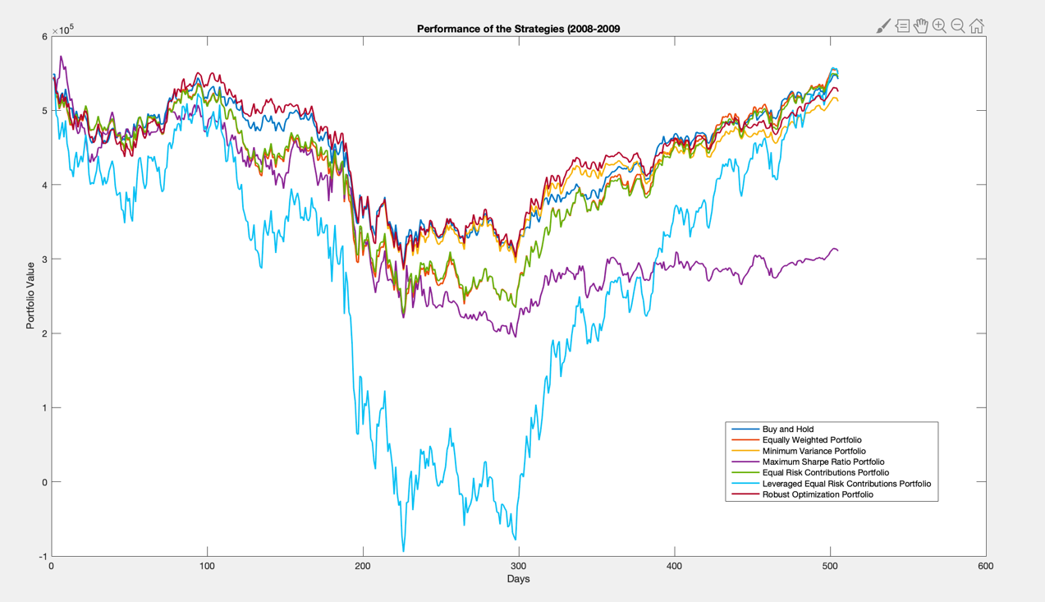

* Plot three charts in MATLAB for strategies 3, 4 and 7 to dynamic changes in portfolio allocations using the new data set.

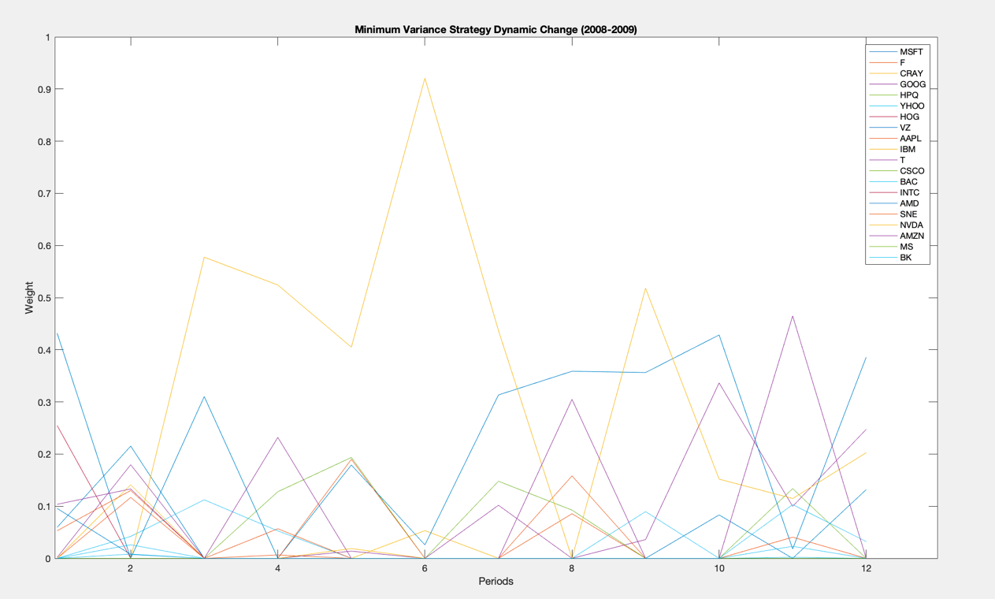

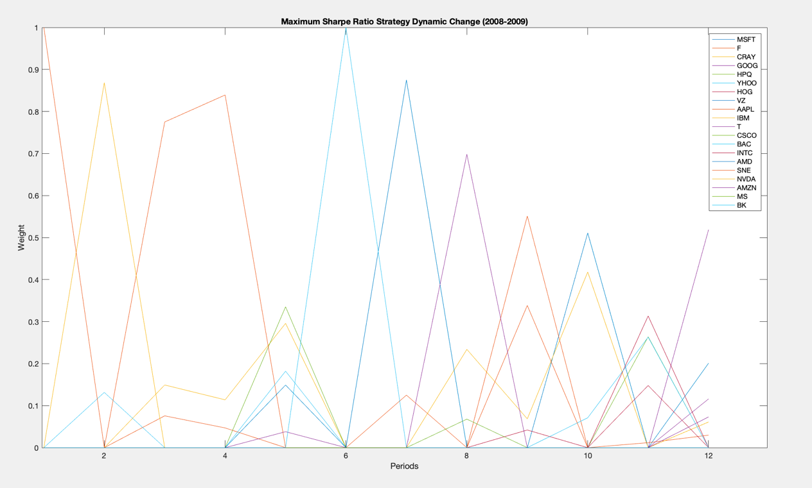

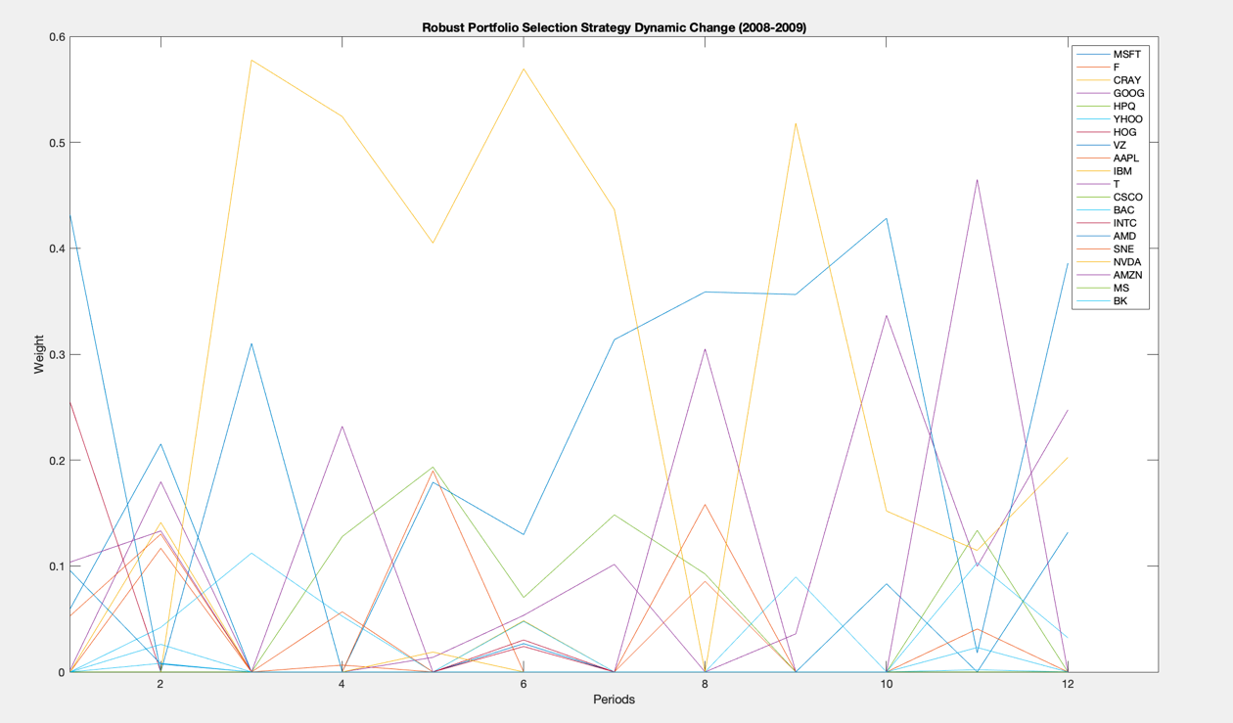

* Does your robust portfolio selection strategy reduce trading as compared with the strategies 3 and 4?

Robust portfolio contains less trading than maximized Sharpe ratio strategy and more trading than minimum variance strategy.

* Compare and discuss relative performance of your seven trading strategies during 2015-2016 and 2008-2009 time periods. Which strategy would you select for managing your own portfolio during 2008-2009 time period and why?

Based on the output and the Performance of the Strategies plot over 2008 and 2009, the robust optimization portfolio has the best and the most stable performance of return. The value of all the seven portfolios show a significant diving around the day 200 and begin to warm up around day 300. The drop of value of leveraged equal risk portfolio is most dramatic and even achieved the negative value. This may due to the financial crisis in 2008, which means the leverage portfolio has the worst risk resistant ability. The value of maximum Sharpe ratio portfolio fails to grow up again after the crisis and stay around its worst case. So this strategy is also not stable.

Comparing the performance of seven strategies during 2015-2016 and 2008-2009, both Leverage Equal Risk portfolio and maximum Sharpe ratio portfolio have striking value changes over 12 periods and are really unstable. Their performances closely follow the economic situation in each time period. The robust mean-variance portfolio is the most stable one during both 2015-2016 and 2008-2009. And other portfolios perform similarly between 2015-2016 and 2008-2009.

For managing my own portfolio during 2008-2009, I would choose Robust Optimization Portfolio, since the value of this portfolio over 12 periods is the stable. This portfolio has the highest return in worst case and has a moderate return among the 7 strategies in the good economic situation.